Lesson 1: Light and wave motion
Demonstration
- What happens when you shine white light through a prism?

- What colors do you see?

- Why do you think light separates into different colors?

Note taking
- What is a photon?

- How do photons travel?

- Sketch a wave. Be sure to label the crest, trough, and wavelength.

- Look at these two waves.
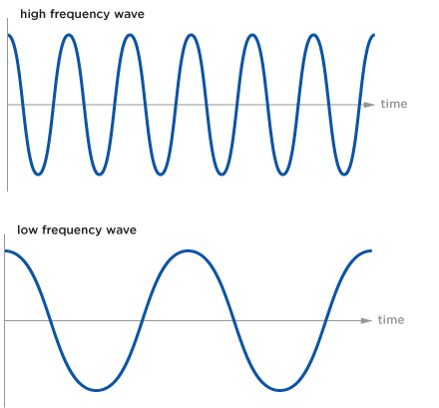
How many wavelengths do you see?

How many wavelengths do you see?

What is the difference between these two waves?

- What is frequency?

Investigation:
- What did you notice about the relationship between frequency and wavelength?

- Complete the following sentence pair.
A wave with a long wavelength has a _________________ frequency.
A wave with a short wavelength has a _________________ frequency.

Conclusion:
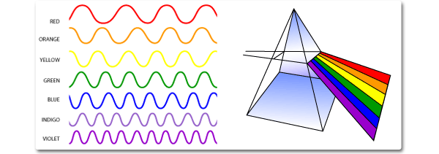
Look at the drawing above. What do you notice about the wavelength and frequency of the red light wave compared with the violet light wave?

Given what you have learned about frequency and wavelength today, why do you think the white light separated into its component colors as it travelled through the prism?

What are two things you learned about light during today’s lesson?

How do you think this information about light will help us learn more about objects in space?

Approved for Public Release: NG17-1826, 9/15/17

