The Electromagnetic Spectrum
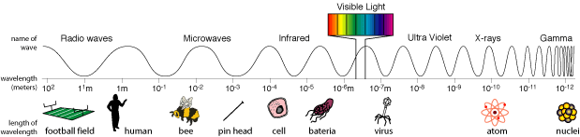
The electromagnetic spectrum is made up of 7 different regions as shown below.
http://science.hq.nasa.gov/kids/imagers/ems/
Directions: Cut apart the pictures on the Uses of the Electromagnetic Spectrum worksheet. Conduct research using http://missionscience.nasa.gov/ems/ to determine which region of the electromagnetic spectrum is associated with each image. Glue the correct picture in the correct space.
Region of the Electromagnetic spectrum | How we use this type of radiation on Earth | How astronomers use this type of radiation to understand the Universe | 1 interesting fact about this type of radiation
Radio waves
Microwaves
Infrared
Region of the Electromagnetic spectrum | How we use this type of radiation on Earth | How astronomers use this type of radiation to understand the Universe | 1 interesting fact about this type of radiation
Visible light
Ultra violet
X-rays
Gamma

What are two things you learned today?
Uses of the Electromagnetic spectrum
This type of radiation carries television and radio signals on Earth. | 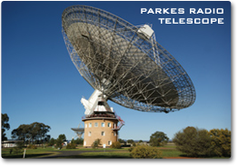  This type of long- wavelength radiation is used by NASA to communicate. | 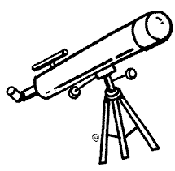  Backyard astronomers use this type of radiation to study the stars. | 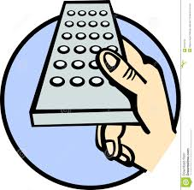  The remote control for your television uses this type of radiation
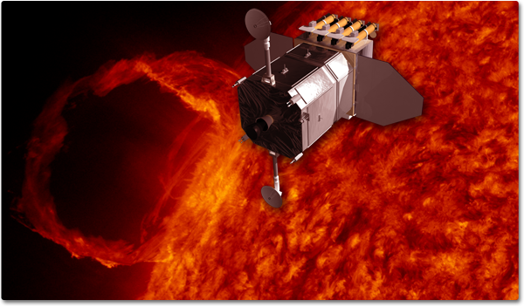This type of radiation is used to study the heat from solar flares on the sun. | We see this type of radiation. | 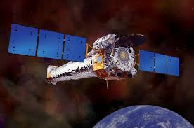  The Chandra Space telescope uses x-ray radiation to study distant objects within our galaxy. | 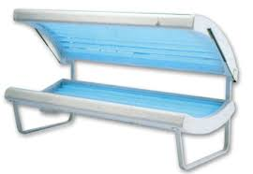  Tanning beds use this type of radiation to help you get a tan.
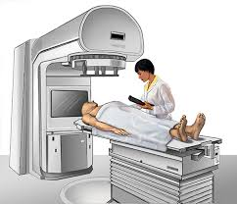  This type of radiation can be used to treat cancer. (it also can cause cancer) | 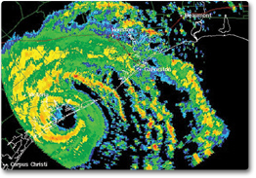  This type of radiation is used by satellites in space to help forecast the weather. | 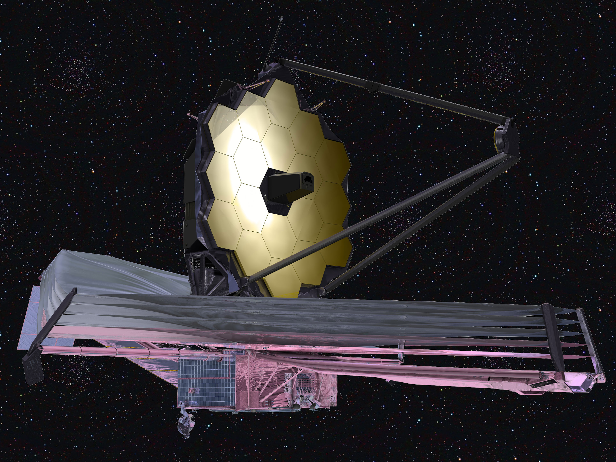  The James Webb space telescope will use this type of radiation to study deep space. | 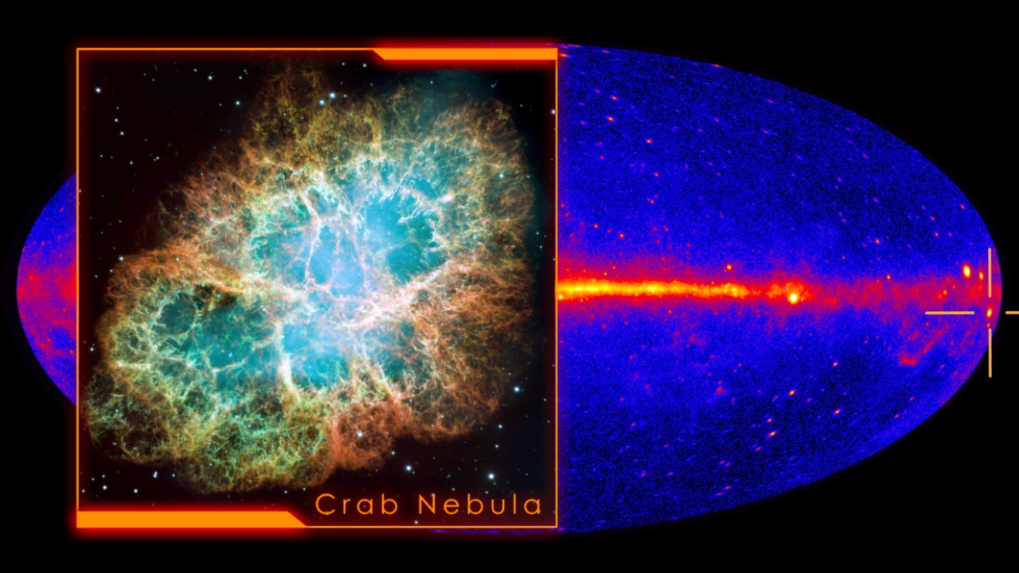  NASAs Fermi space telescope uses gamma rays to study objects both inside and outside of our galaxy.
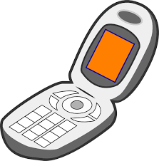  Cell phones and your microwave oven both use this type of radiation. | 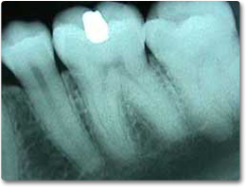  We use this type of radiation to monitor bone and tooth health

Approved for Public Release by NASA, 9/26/17; NG17-1826

